**Program No.06**

**Program title** *Flame Sensor*

**Aim**

To create a Flame Sensor

**Hardware Required**

Arduino board

Temperature sensor (tmp36)

Buzzer

Led

**Circuit**

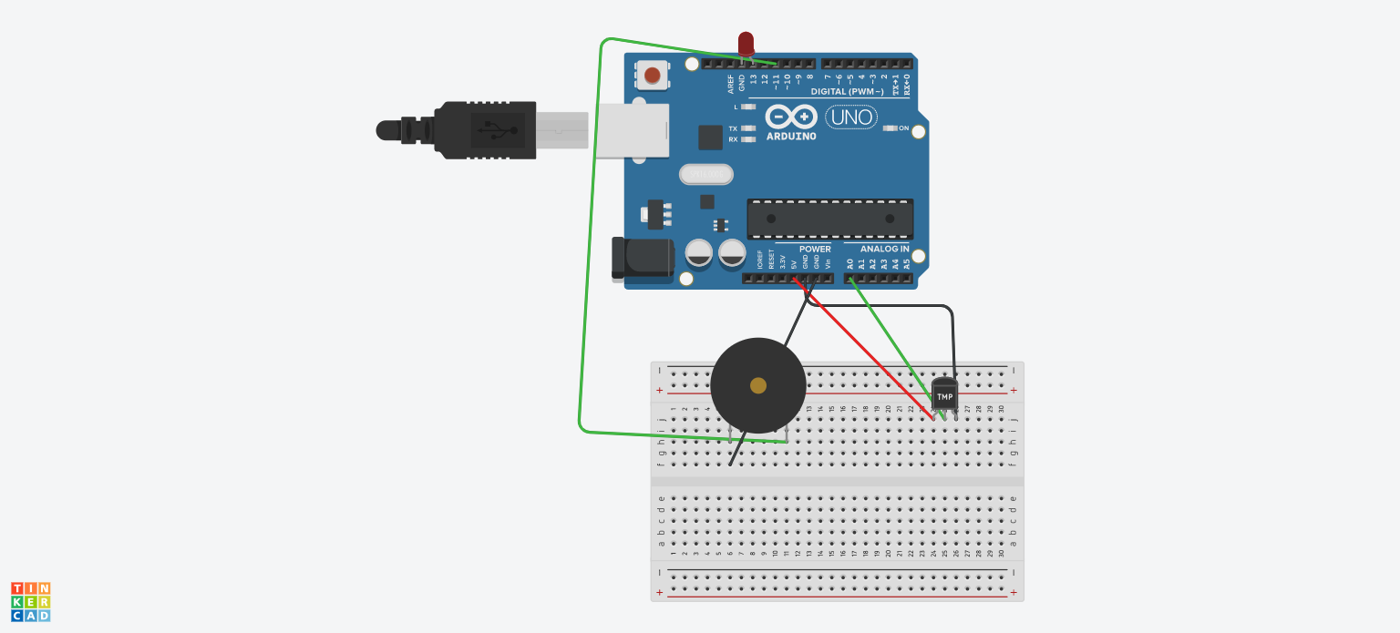

**Code**

**void setup()**

**{ Serial.begin(9600);**

**pinMode(13, OUTPUT);**

**pinMode(11,OUTPUT);**

**}**

**void loop()**

**{**

**int value = analogRead(A0);**

**float milivolt=(value/1024.0)*5000;**

**float celsius=milivolt/10;**

**Serial.print("\ncelsius=");**

**Serial.print(celsius);**

**delay(1000);**

**if(celsius>37){**

**digitalWrite(13,HIGH);**

**digitalWrite(11,HIGH);}**

**else{**

**digitalWrite(13,LOW);**

**digitalWrite(11,LOW);}}**